Module 07

Title: Amazon Web Service

Objective: To demonstrate and implement IAAS service using AWS (Use t2.Micro (Free tier eligible) (instance only).

Technology: AWS

Theory:
Step 1 -: Login to AWS portal and Select EC2 service from admin console
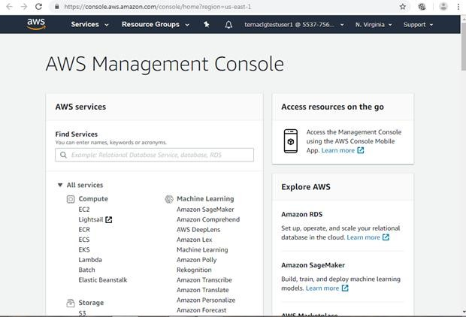

Step 2-: The EC2 resource page will appear which will show you the summary of instances. Now click on launch instance to select the VM instance type
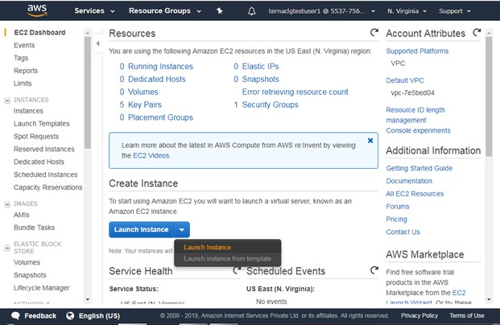

Step 3-: Select the operating system type in AMI format. In this example we have selected Windows server instance which is eligible for free tier and click on Next.
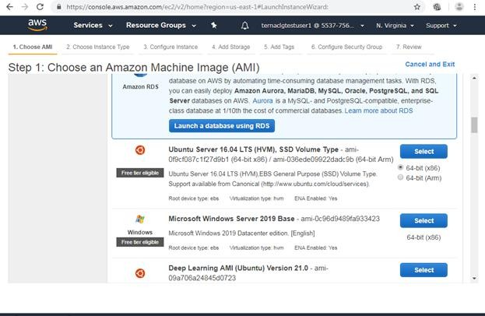

Step 4 -: Now select the hardware type for Virtual machine. In this example we have selected free tier eligible General purpose hardware and click on Next.
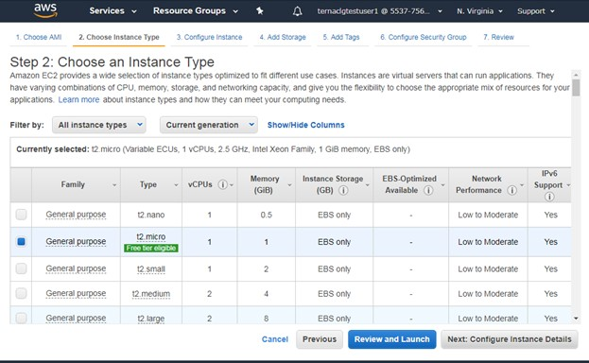

Step 5-: Now specify the instance details like Number of instances, networking options like VPC, Subnet ot dhcp public IP etc. and click on Next
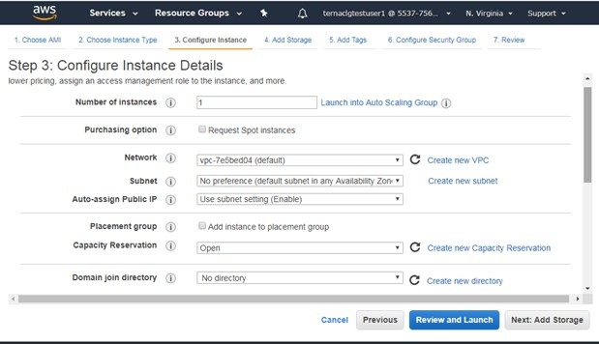

Step 6-: Specify the storage space for VM and click on Next
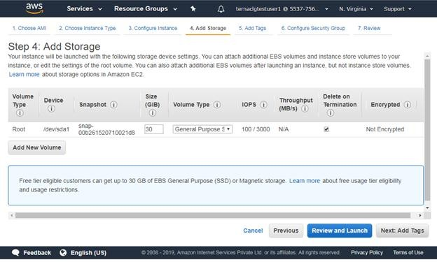

Step 6-: Click on Add tag to specify VM Name and click on Next
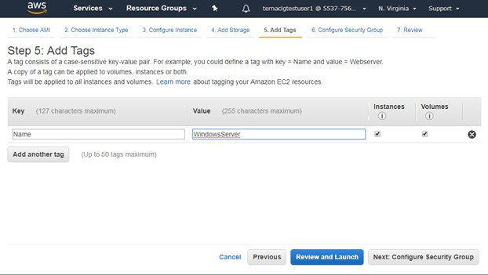

Step 6-: Configure security group to provide access to VM using different protocols.In this example we have selected default RDP protocol.
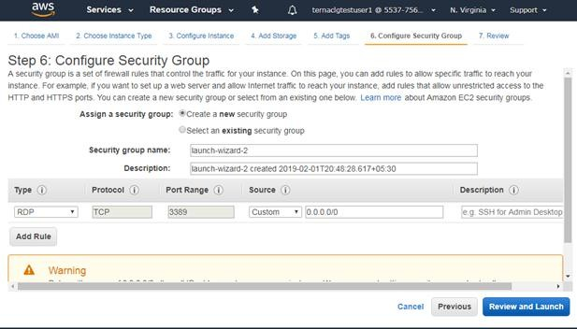

Step 7-: Now Review the instance and click on Launch button

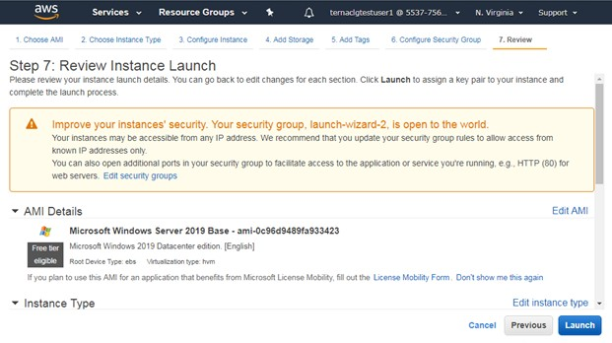

Step 8-: Now to secure VM instance, Encrypt it using public key and create a private key pair to decrypt that. Here specify key pair name and download key pair.
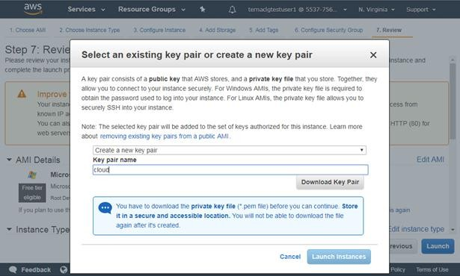
Step 8-: Finally Click on launch instance to Launch VM
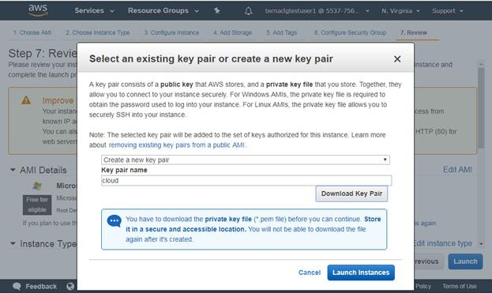

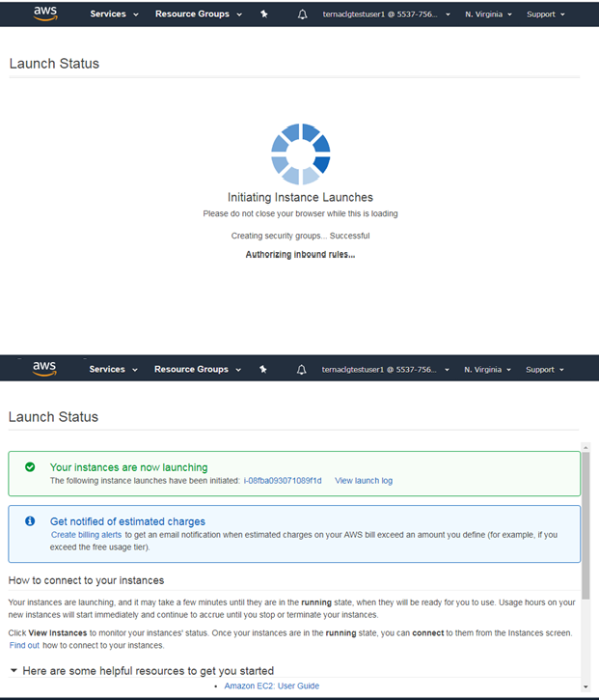
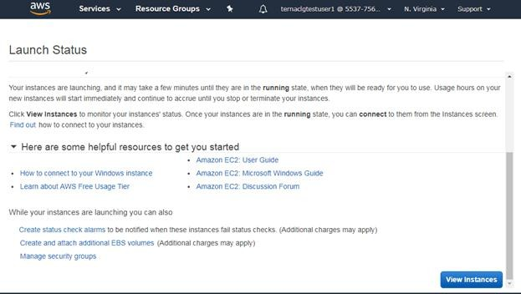

Step 9-: Now from summary page click on View instance to see the instance state. Afte some time you will see the running instance of your VM.

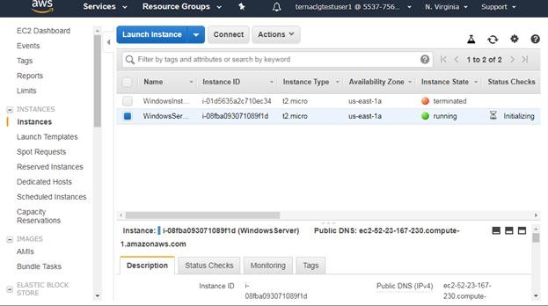

Step 10-:Now Click on Connect to get the password for VM to access it over RDP protocol.
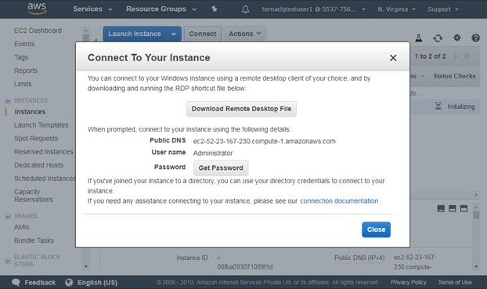
Step 11 -: Select the downloaded key pair file to decrypt the password.
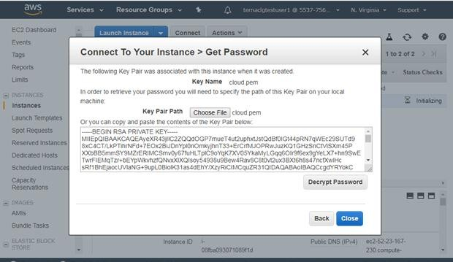

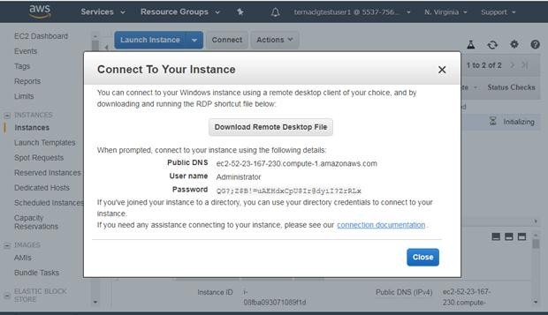

Step 12 -: Now connect the instance using RDP tool by using Ipaddress/DNS, username and Password decrypted in last step.
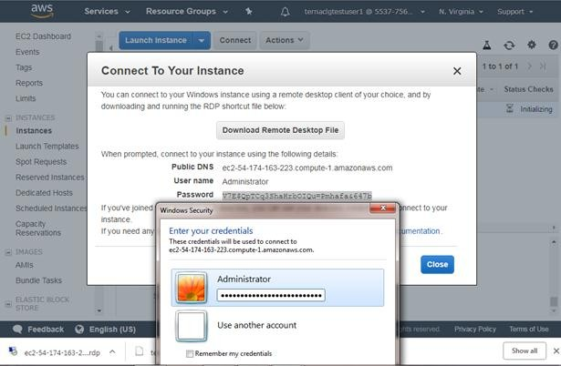
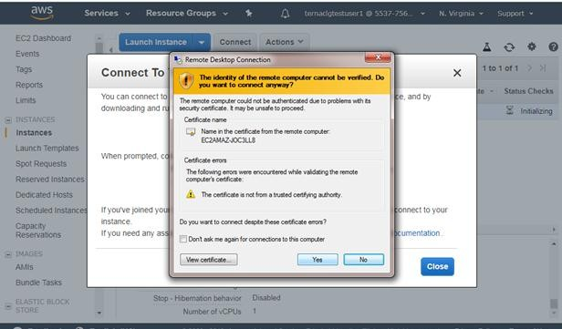
Step 13-: Once you click on connect, you will see the running Windows virtual machine as shown below.
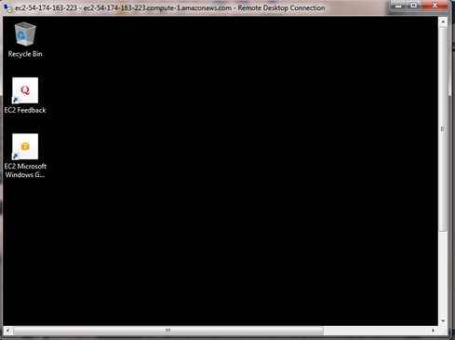

Step 14-: You can shut down instance by selecting instance state followed by stop
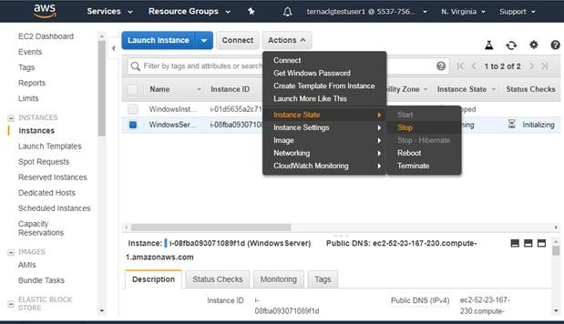

Step 15-: You can delete the instance permanently by selecting instance state followed by stop

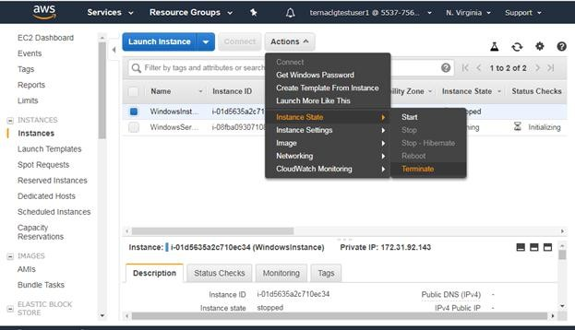
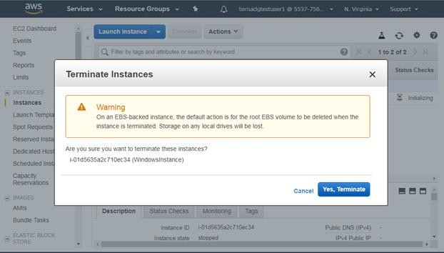

2) To create simple word press app using Light sail service in AWS (SAAS) Step 1-: Open Admin console of AWS and select light sail service
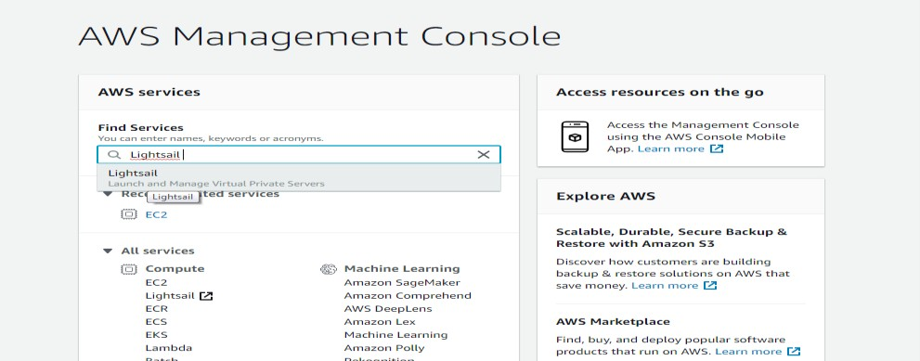

Step 2-: Select Create instance option
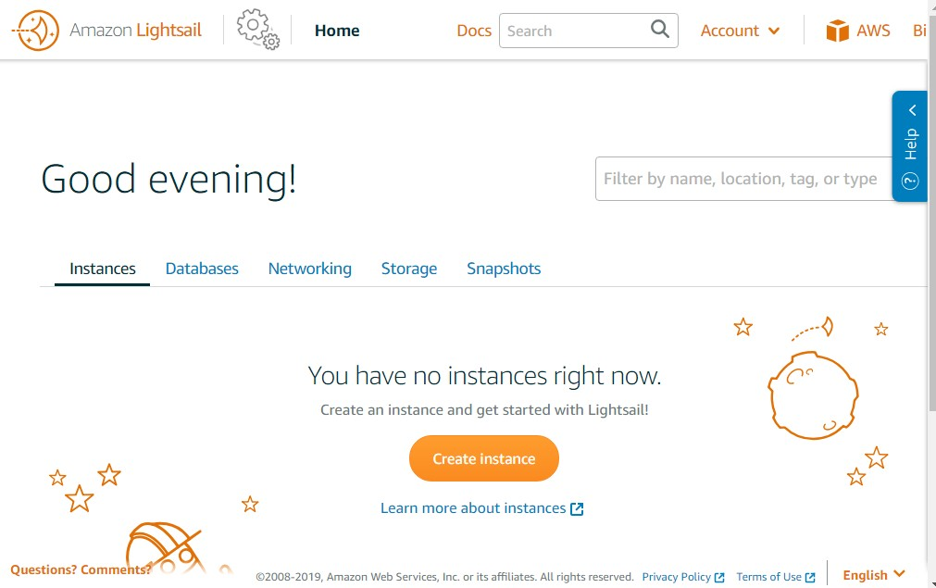

Step 3 -: Select the Linux hosting instance
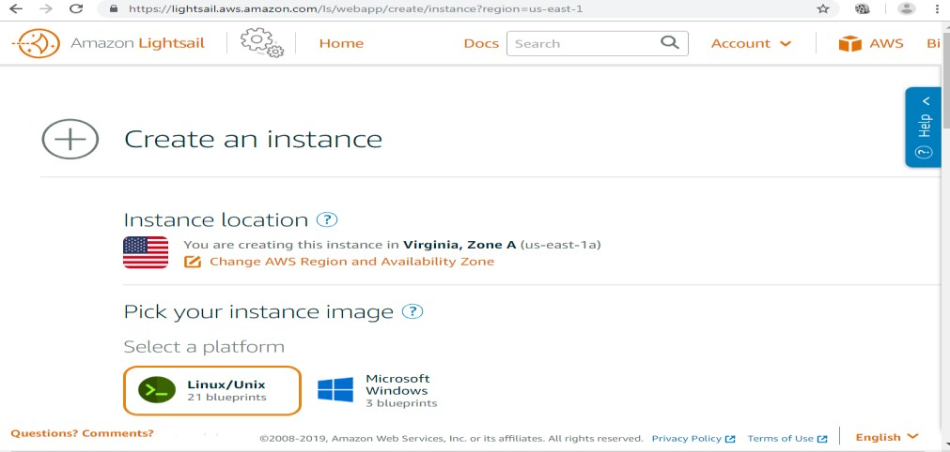
Step 4 -: Select word press hosing
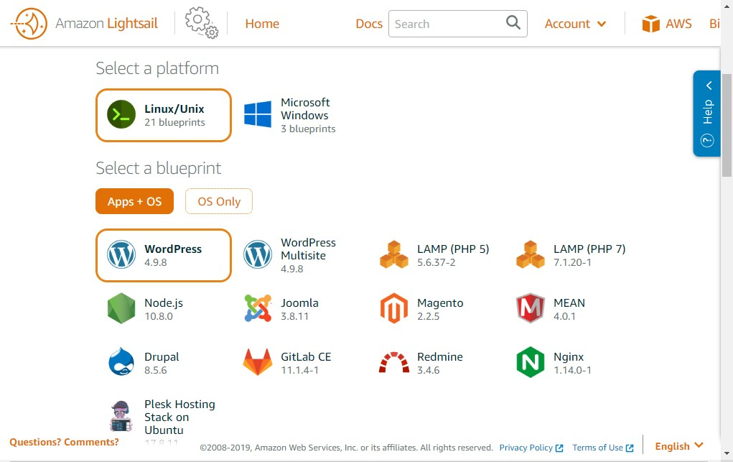
Step 5 -: Specify name to the instance
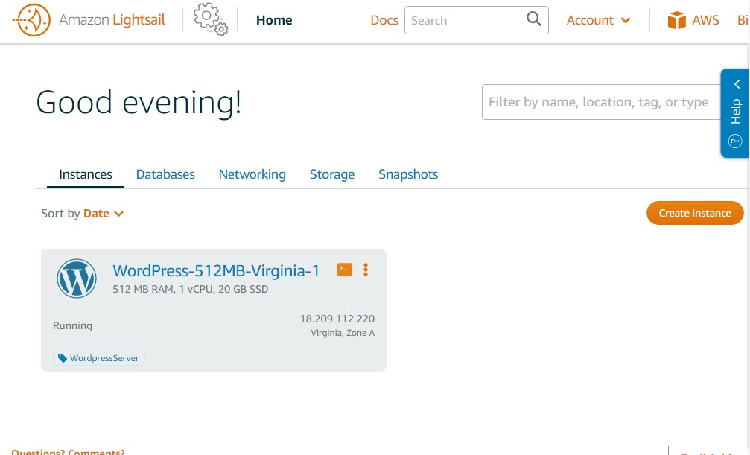
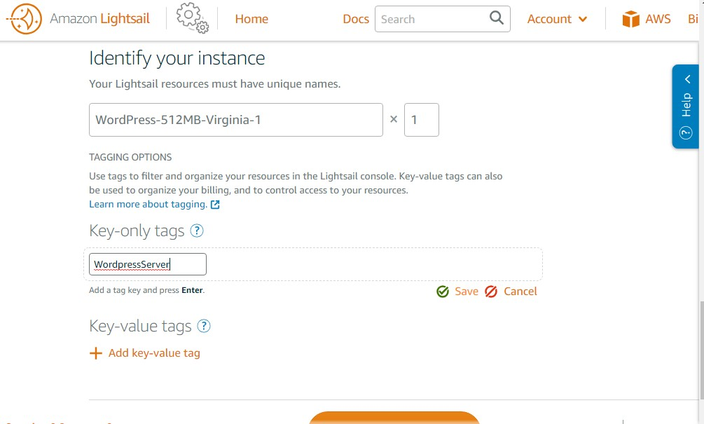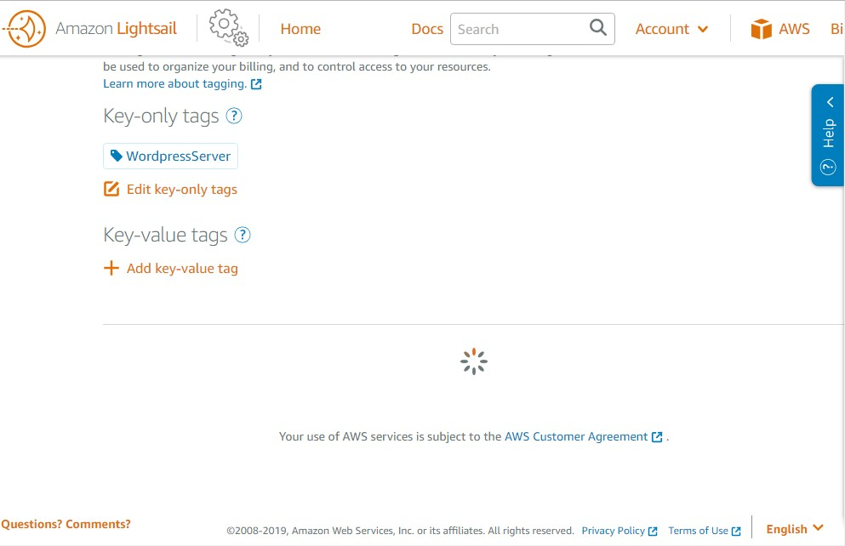Step 6-: Now click on create to launch the instance Step

Step 7 -: Click on connect instance to get the password for word press
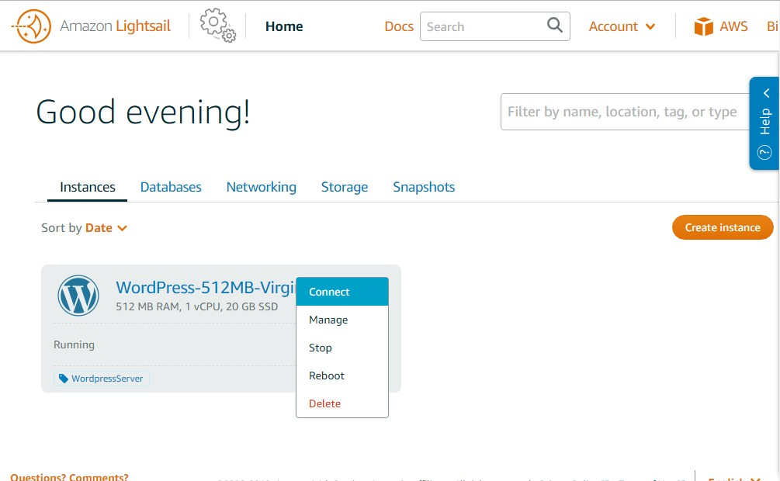

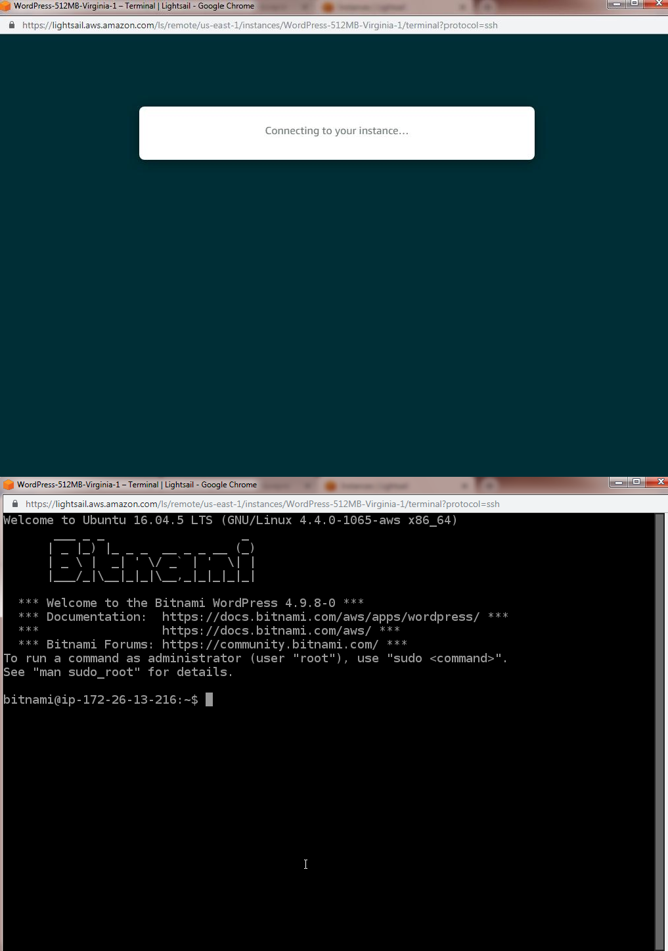

Step 8-: Now open bitnami_application_password file to get the admin password. So copy it and use over admin console
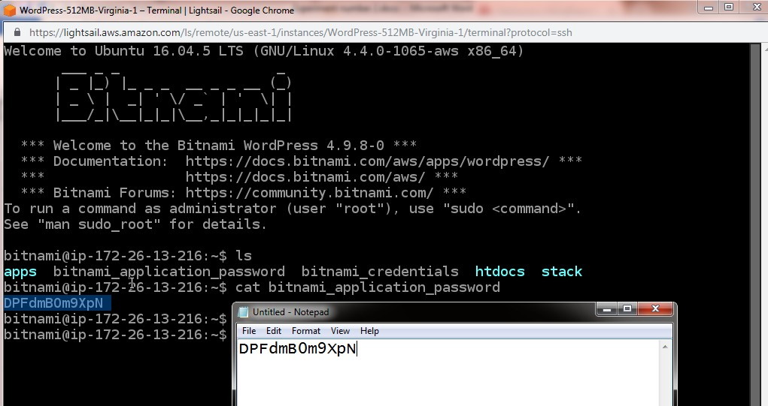

Step 9 -: Now researve static ip by selecting network option and creating static IP
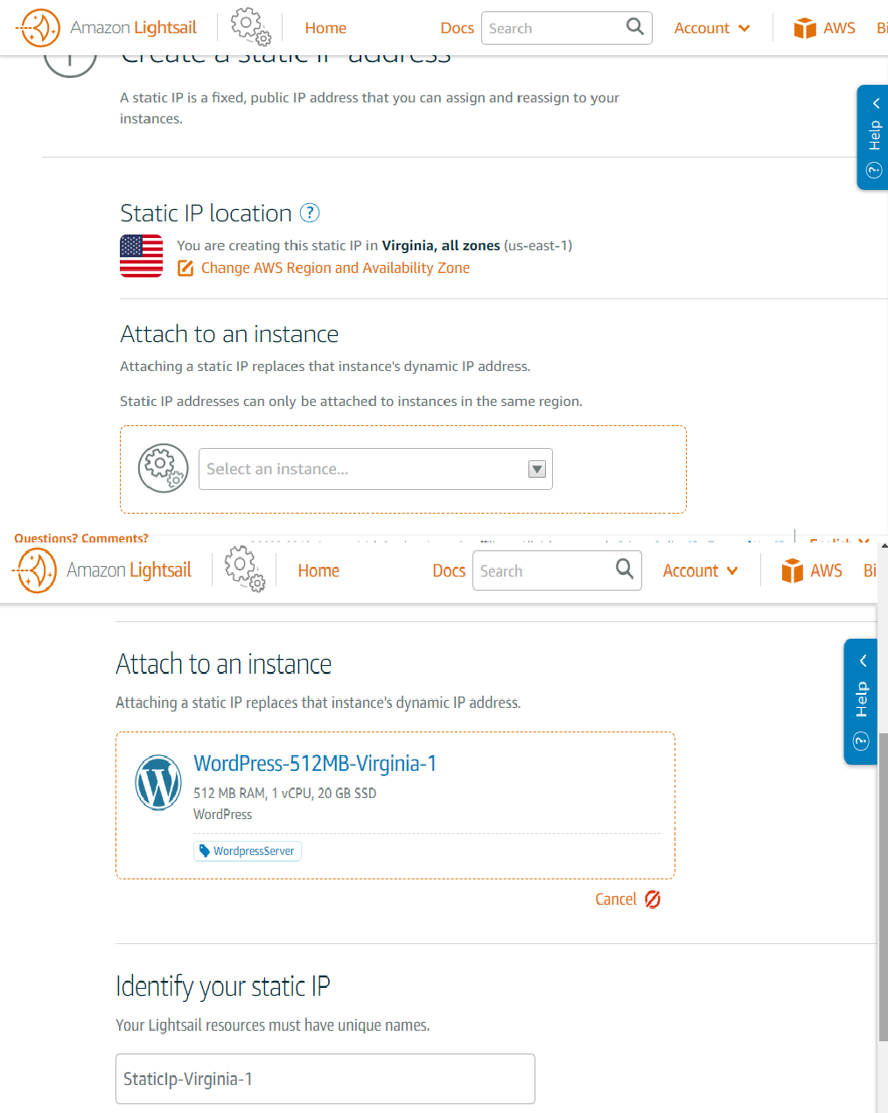

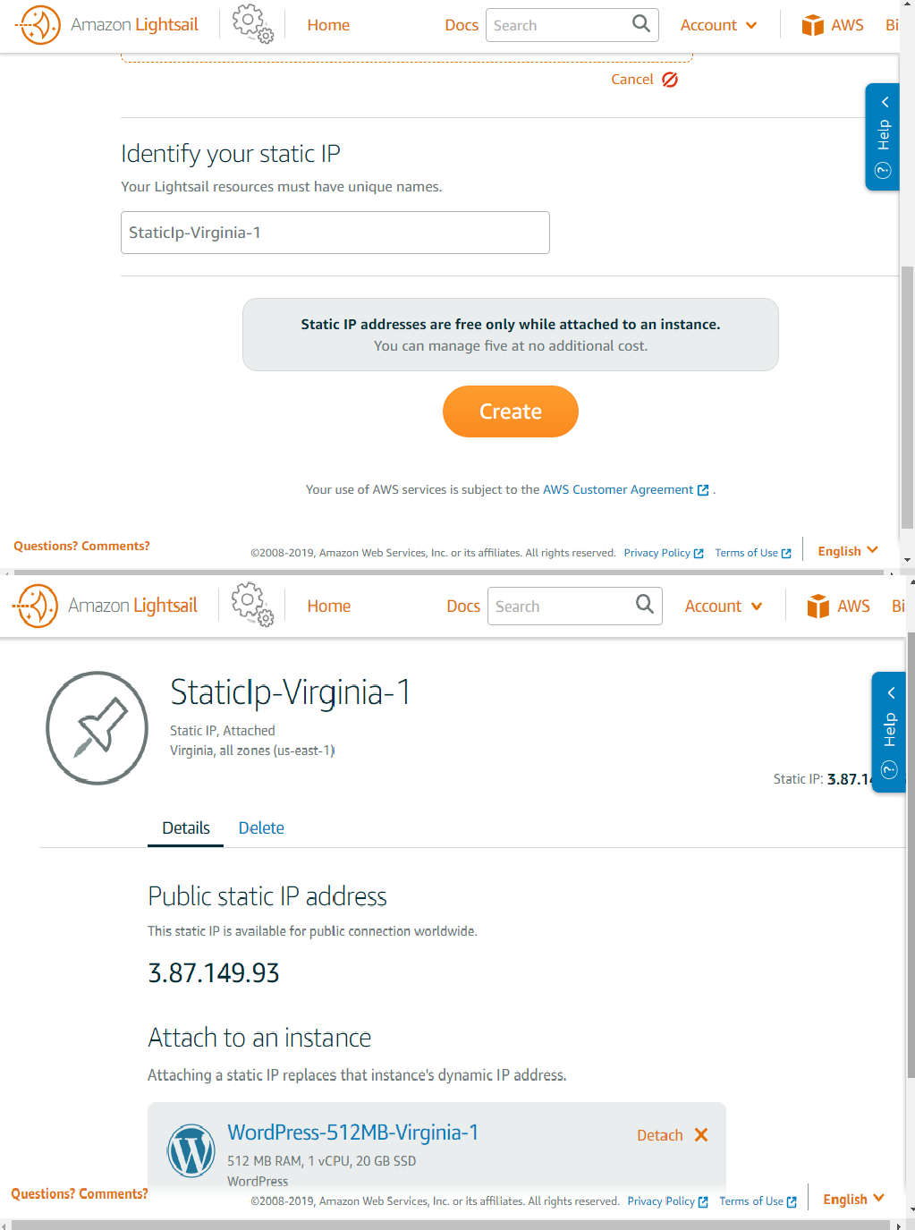

Once static IP is allocated then open that ip on browser to see Word press Website

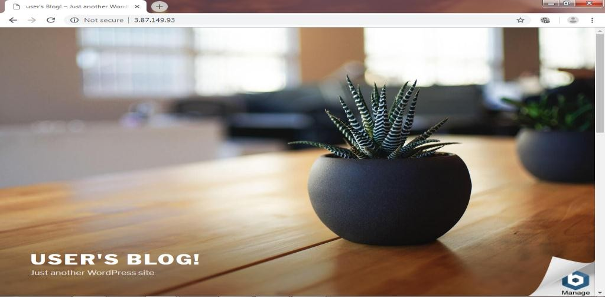

Open admin console of Word press and use password obtained in step 8 to open word press site builder. Now you can develop a complete Word press website and use that.
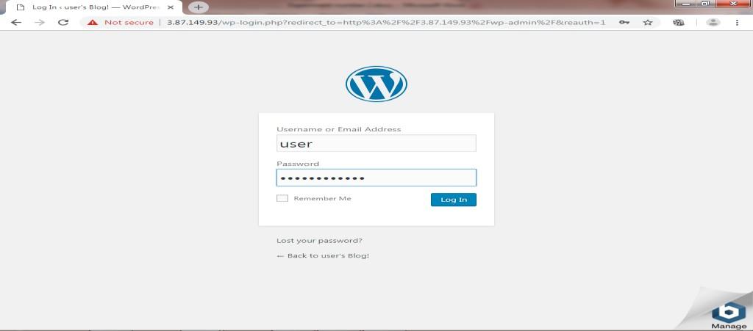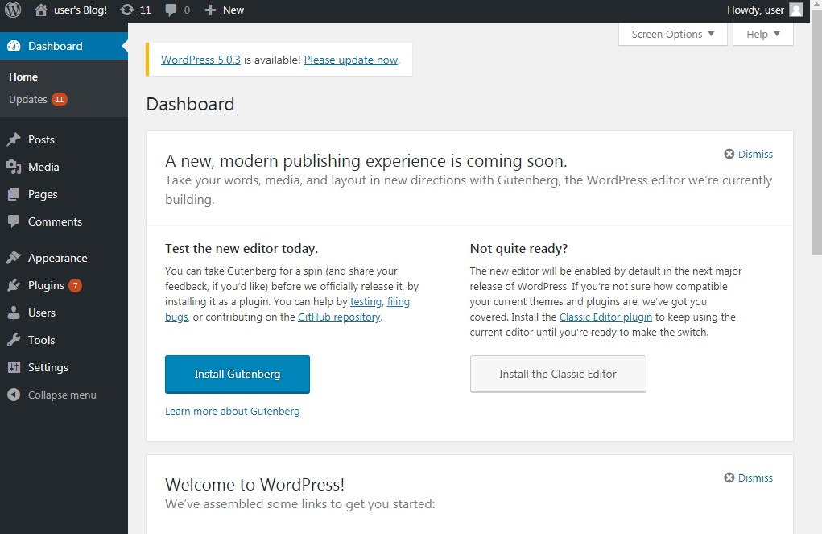

CONCLUSION:

Amazon Web Services (AWS) is a subsidiary of Amazon that provides on-demand cloud computing platforms and APIs to individuals, companies, and governments, on a metered pay-as-you-go basis. Subscribers can pay for a single virtual AWS computer, a dedicated physical computer, or clusters of either.

Program  Execution/  formation/  correction/  ethical practices  (07) | Documentation  (02) | Punctuality  (01) | Viva Answer  (05) | Experiment  Marks (15) | Teacher Signature with date

